Wireframe



**Name: Tony Jiang**

**Date: 19 Sep 23**

**Project: Video call system**

|  |  |  |
| --- | --- | --- |
| Version | Date | Description |
| 0.1 | **19 Sep 2023** | **Initial document.** |
| 0.2 | **20 Sep 2023** | **Correct spelling errors.** |
| 1.0 | **21 Sep 2023** | **Approved by the company mentor.** |
| 1.1 | **27 Sep 2023** | **Change some wireframes.** |
| 1.2 | **5 Oct 23** | **Add 2 wireframes for the first design, in the initial start.** |
| 1.3 | **6 Oct 23** | **Make single quotes to double quotes.**  **Add a little addition to the “First design” and “Second design”.** |
| 1.4 | **18 Dec 23** | **Add additional feature.** |
| 1.5 | **20 Dec 23** | **Fix some spelling error.** |

Contents

1 Introduction 4

2 Wireframe initial concept 4

2.1 video call button on the appointment form 4

2.2 The process of making a video call 5

2.2.1 First design 5

2.2.2 Second design 11

2.3 The process of end call 14

2.4 Other components 16

2.4.1 Mute microphone 16

2.4.2 Turn off camera 16

3 Additional features 17

3.1 Concept 1 17

# Introduction

This document contains wireframe sketches outlining the design of the video call system, along with a step-by-step guide on how to navigate from point A to point B and an explanation of the functionality. Throughout the process, new wireframes will be added, accompanied by explanations of the purpose and the day of their design. Please note that some of these sketches may not represent the final product appearance but are intended to give an idea of the design concept to others and explain the reasoning behind it.

# Wireframe initial concept

***Date created: 19 September 23***

## video call button on the appointment form

The SVb employee needs to initiate the video call to the retirees based on their scheduled appointments. When the due date arrives, they access the appointment form and make a video call. To simplify the process, the idea is to add a video call button directly to the appointment form for easy access, eliminating the need for the SVb employee to navigate to other forms. This is the purposed design.

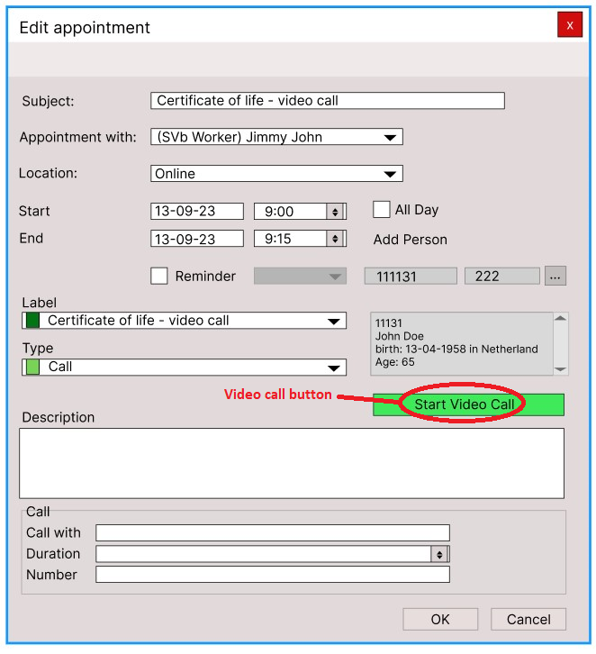

Figure 1: The video call button.

## The process of making a video call

There are 2 design approaches for initializing the video call process. We will go into detail how each design works and the process of how it will look like.

### First design

This first design is in connection with the “Concept 1” in the **Concept Document,** this will give an idea of what the first concept is and what the design of it will look like. In the first design, after interacting with the “Start Video Call” button, the system will prompt the SVb employee with a small form displaying the mobile phone numbers. The purpose of this is to provide the SVb employee with the option to choose which mobile phone number to use for the video call, especially if a retiree has 2 mobile phone numbers. If the retiree has only one mobile phone number, the form will display that single number. However, if the retiree doesn't have any mobile phone numbers on record, a message will appear when interacting with the “Start Video Call” button, stating that 'This retiree doesn't have a mobile phone number on record.

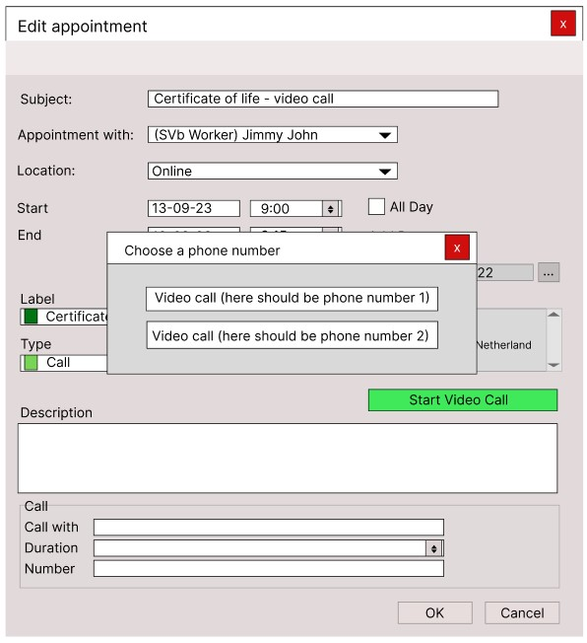

Figure 2: Display 2 mobile phone numbers.

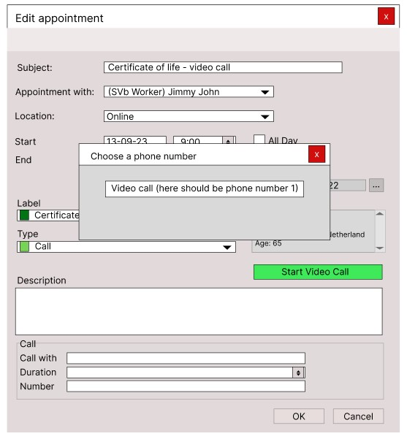

Figure 3: Display 1 mobile phone number.

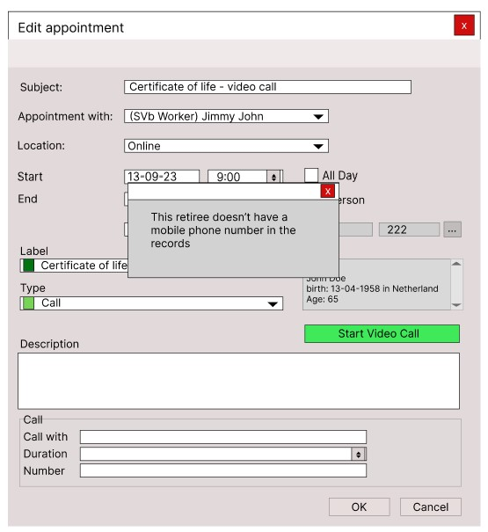

Figure 4: Display no existing mobile phone number.

After choosing a phone number, the system attempts to contact the retiree. The SVb employee receives visual confirmation that the system is attempting to contact the retiree, so that the SVb employee knows what the system is doing. If the retiree didn’t answer or the SVb employee is experiencing internet issues, the system will provide visual feedback to the SVb employee. When the retiree answers the video call, the SVb employee receives visual confirmation of the connection, and a live video feed appears on the screen. The retirees will receive the video call through WhatsApp.

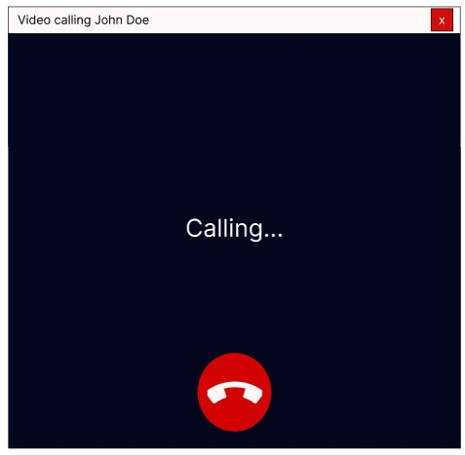

Figure 5: The system is calling the retiree.

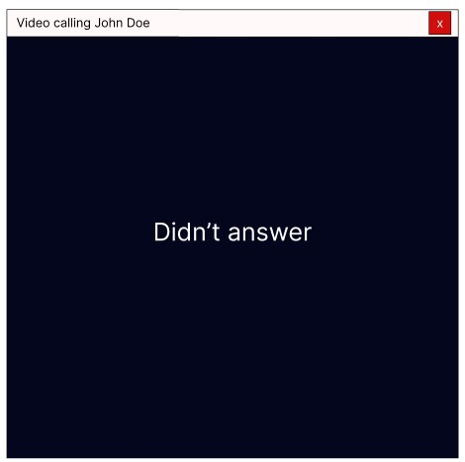

Figure 6: Retiree didn't answer.

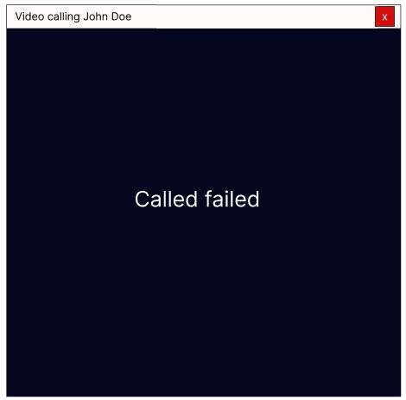

Figure 7: Called failed due to internet connection.

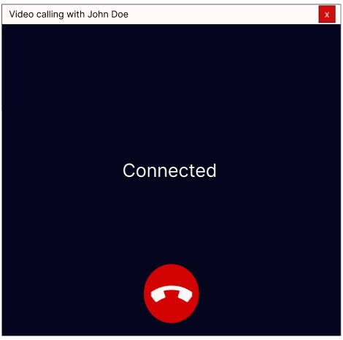

Figure 8: Connected with the retiree.

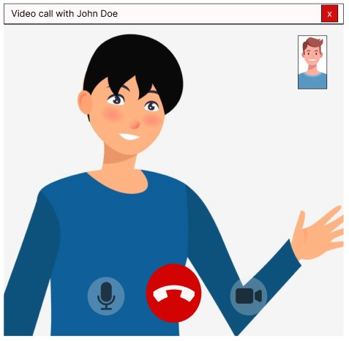

Figure 9: In a call with the retiree.

### Second design

The second design is in connection with “Concept 2” in the **Concept Document**, it will give an overview of what the concept is, and the second design will convey how it will look. In the second design this will be how to initiate a video call. Firstly, a confirmation box will appear when you click the “Start Video Call” button, asking if you are sure you want to make this video call. The idea behind this step is to prevent accidental video calls by the SVb employees. The SVb employee can either choose “Yes” or “No” on the confirmation box. If “No” is selected, the confirmation box will disappear, and nothing will happen. If “Yes” is chosen, the confirmation box will disappear and a new form will appear, initiating the attempt to contact the retiree.

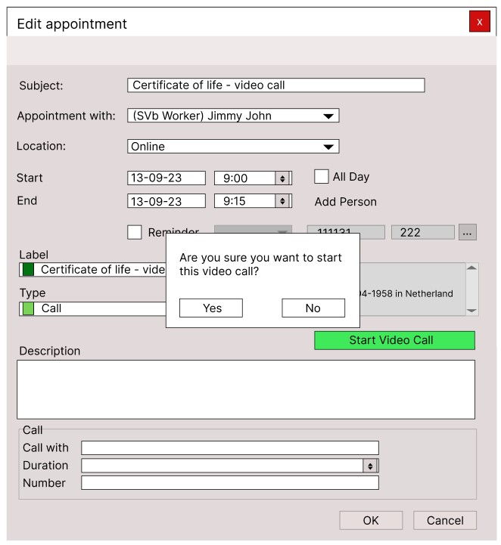

Figure 10: Display confirmation box.

After confirming to start a video call, the system will initiate a video call meeting. In this approach, the SVb employee is placed in a meeting room and waits for the retiree to join the video call meeting. The system will provide visual feedback to indicate when the SVb employee is attempting to join the room. This is similar to popular online meetings like teams and zoom. Retirees can join the meeting through the link provided in their emails or WhatsApp.

Figure 11: Attempting to join the room.

Figure 12: The SVb employee joined the room and is waiting for the retiree.

Figure 13: The retiree is in the room with the SVb employee.

## The process of end call

For ending a video call there are two ways: either by clicking the “End Call” icon or the “Close” button on the top right. Both options prompt a confirmation box, if you want to end the call. This is a precaution for SVb employees who may accidentally click on the “End Call” icon or the “Close” button. If the SVb employee chooses “No”, the confirmation box will disappear, and they’ll remain in the call. If the SVb employee chooses “Yes”, the confirmation box will disappear, the call will end, and the video call form will also disappear. This will work for both methods of initiating the video call. The first method also provides visual feedback indicating that the call has ended.

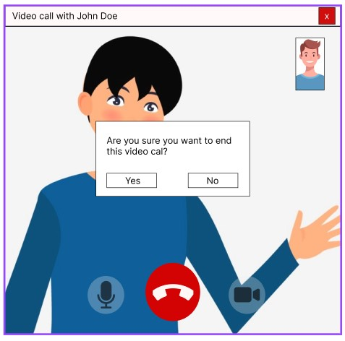

Figure 14: Confirmation box when the “End Call” icon or the “Close” button is clicked.

Figure 15: End call visual feedback.

## Other components

### Mute microphone

The icon for microphone will change when the user mutes the microphone. This is not essential but it’s good to have. It’s mostly for the other user in the call to avoid hearing the background noises.

Figure 16: Mute microphone.

### Turn off camera

The icon for the camera will change when the user turns the camera off. While not essential, it’s a helpful feature, primarily for troubleshooting camera issues because sometimes the camera won’t work initially and needs to be turned off and on again or to avoid showing personal items on the screen. Additionally, it will provide visual feedback indicating that the camera is turned off, in the top right corner of the screen.

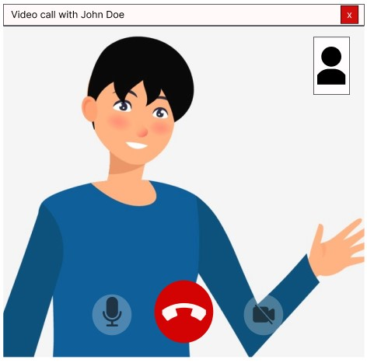

Figure 17: Camera is turned off.

# Additional features

## Concept 1

This additional feature is designed for Concept 1. It allows SVb employees to easily call the number provided in the description. They can copy the number from the description field and paste it, or manually type it. To initiate the process, they have to click the “Start Video Call” button, which opens a form for pasting or typing the number. Once the number is entered, they can press the 'Video Call' button to initiate the video call.

Figure 18: Paste or type the number feature.